Assessment Schedule – 2016
Mathematics and Statistics: Apply calculus methods in solving problems (91262)
Evidence Statement
Q | Expected Coverage | Achievement (u) | Merit (r) | Excellence (t)
ONE  (a) | f '(x) = 12x² – 14x + 2  f '(2) = 48 – 28 + 2  = 22 | Derivative found and gradient evaluated.
(b) | f ' = 6x – 2  tangent gradient = 1  6x – 2 = 1  x = 0.5 y = 3.75  Coordinates (0.5,3.75) | Derivative found and gradient used.  E.g. f '(0.5) or  f '(x) = 1. | Using f(0.5) to find 3.75 or use the straight line formula to verify tangent equation.
(c) | For turning point  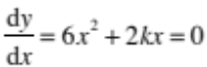  When x = 1, k = –3  Maximum turning point when  6x² – 6x = 0  x = 0 or x = 1  Maximum turning point at  (0,5) | Derivative found and equated to 0, and  k = –3 evaluated. | Coordinates of maximum turning point found.
(d) | At the point (3, 4)  the gradient  = 0  2 × 3 – a = 0  a = 6  y = x² – ax + c  = x² – 6x + c  4 = 9 – 18 + c  c = 13  y = x² – 6x + 13 | Derivative equated to 0 and a = 6 evaluated. | Anti-derivative found.  y = x² – 6x + c | Equation correct – can be left as c = 13.
(e) | y = x⁴ – 4x³  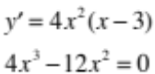  x = 0 or 3.  Minimum x = 3, and y = –27 | Derivative found and equated to 0. Can be implied from solving. | Both x values found. | Confirmed that x = 3 for the local minimum giving y = –27 justified by reference to graph, gradient on either side or second derivative.

Evidence Statement
NØ | N1 | N2 | A3 | A4 | M5 | M6 | E7 | E8
No response; no relevant evidence. | Attempt at one question. | 1 of u | 2 of u | 3 of u | 1 of r | 2 of r | 1 of t | 2 of t

Q | Expected Coverage | Achievement (u) | Merit (r) | Excellence (t)
TWO  (a) | 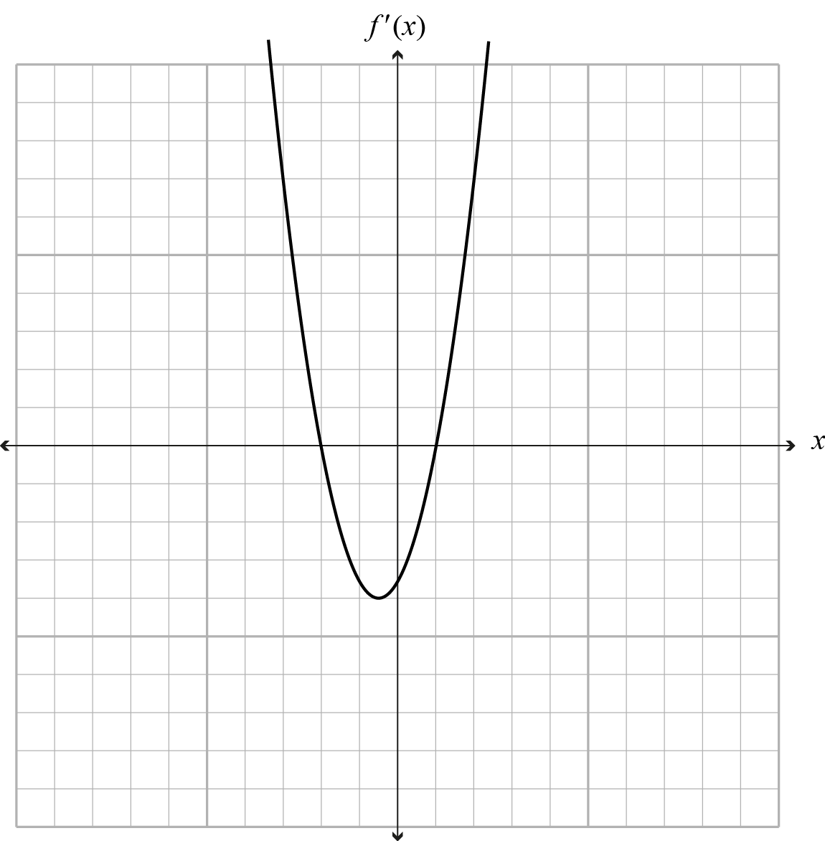 | Parabolic shape with intercepts at  x = –2 and x = 1
(b) | Question Two (b) has been amended from that used in the examination, and this answer has been amended to match.  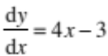  at (2,3) m = 5  therefore a = 5  3 = 5 × 2 + b  b = –7 | Derivative found and  m = 5 evaluated. | a (or m) and b evaluated.  Can be expressed as  y = 5x – 7.
(c) | f '(x) = –4 + 10x + 3ax²  –4 + 10x + 3ax² = 3  = gradient when x = 1  3 = –4 + 10 + 3a  3a = –3  a = –1 | Derivative found and equated to 3. | a evaluated.
(d) | A = π (0.1t + 2)²  = π (0.01t² + 0.4t + 4)  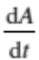 = 0.02πt + 0.4π  r = 10  0.1t = 8  t = 80  = 1.6π + 0.4π  = 2π cm² s^{–1} or equivalent. |  | Relationship formed and derivative found (units not required). | Rate of change of area calculated, units not required.  2π = 6.28 (2dp).
(e) | 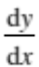= 9x² – 4a² < 0  9x² < 4a²  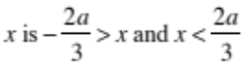  Decreasing function between 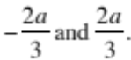  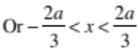  Or clearly shown on a graph. | Derivative found. | x evaluated or equivalent. | Interval found.

Evidence Statement
NØ | N1 | N2 | A3 | A4 | M5 | M6 | E7 | E8
No response; no relevant evidence. | Attempt at one question. | 1 of u | 2 of u | 3 of u | 1 of r | 2 of r | 1 of t | 2 of t

Q | Expected Coverage | Achievement (u) | Merit (r) | Excellence (t)
THREE  (a) | y = x³ – 5x + c  c = 4  y = x³ – 5x + 4 | Equation found.
(b) | 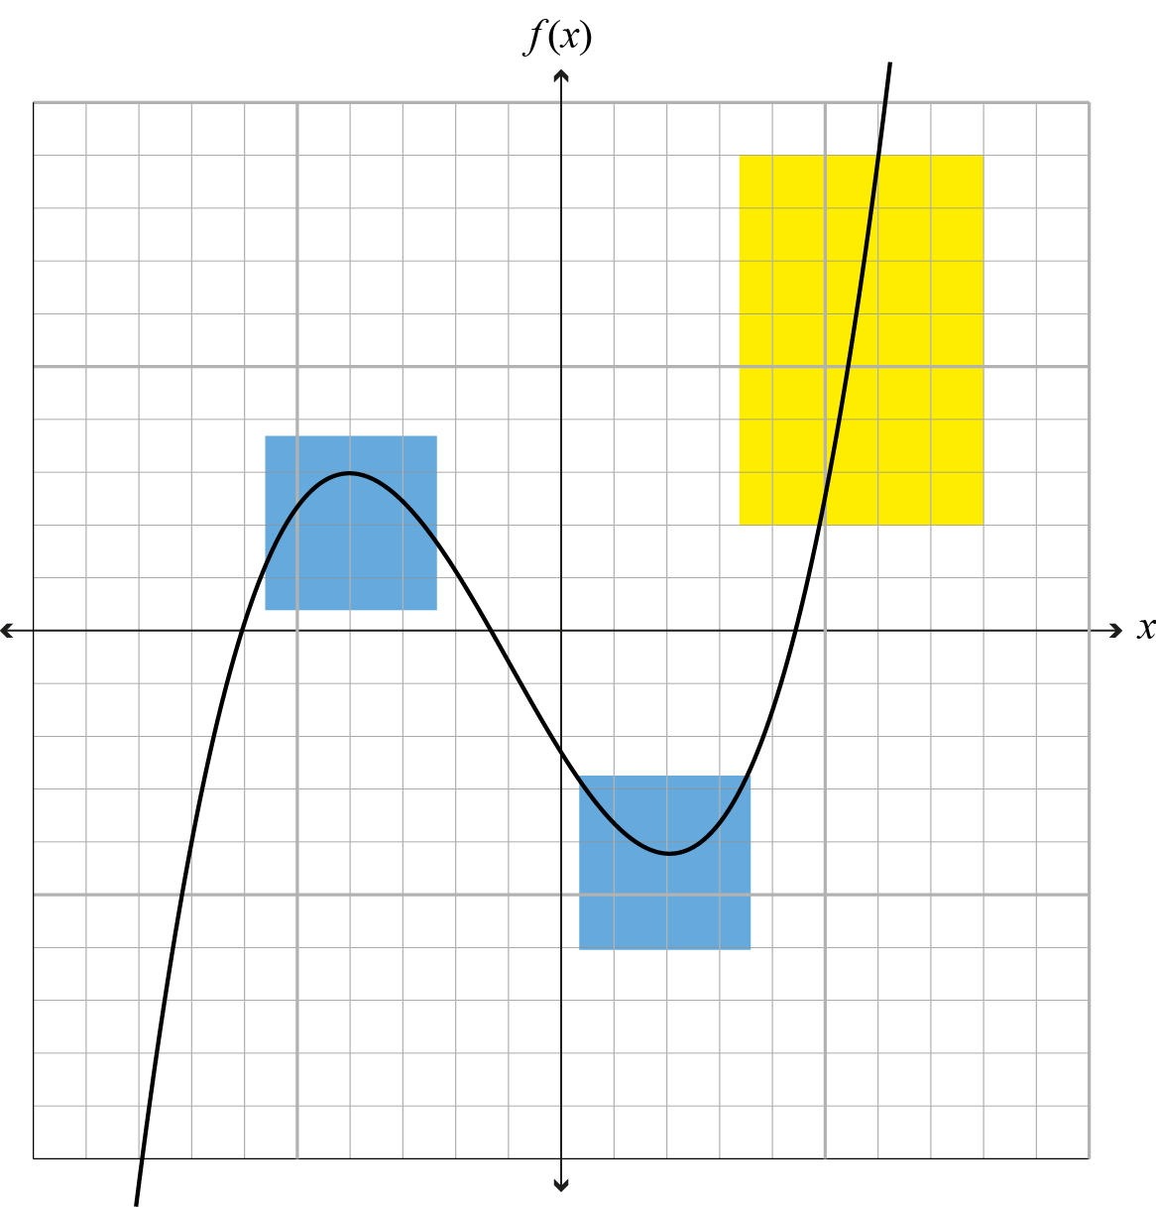 | Positive cubic shape or negative cubic with correct turning points. | Positive cubic shape and  turning points at x = –4 and x = 2.
(c)(i) | a = 0.6  v = 0.6t + c  t = 0, v = 5  v = 0.6t + 5  rate after 10 seconds  = 6 + 5  = 11 (m s^{–1}) | Anti-derivative formula found.  Obvious use of any physics formula, without calculus, not accepted. | Velocity formula must contain variable t and show evidence of t = 0,  v = 5.  Speed after 10 seconds found, units not required.
(c)(ii) | s = 0.3t² + 5t + c  t = 0, s = 0, c = 0  s = 0.3t² + 5t  v = 8  0.6t + 5 = 8  t = 5  s(5) =0 .3 × 5² + 5 × 5  = 32.5 m | Distance equation formed with +c. | Finds the distance formula evidence of t = 0, s = 0,  c = 0.  AND finding t = 5  when v = 8. | Finds the distance travelled, units not required.
(c)(iii) | v = 8  a = –0.2  v = –0.2t + c  t = 0, v = 8, so c = 8  y = –0.2t + c  s = –0.1t² + 8t + c  t = 0, s = 0, so c = 0  6 = –0.2t + 8  0.2t = 2  t = 10  distance after 10 seconds = 70  Distance past P = 102.5 m | Anti-derivative found. | Finds the distance formula evidence of t = 0, s = 0,  c = 0 AND finding t = 10 when v = 6. | Alternate method  c = 9, t = 15, get to 102.5 m without getting 70 m first.  Calculated the distance travelled past P. Units not required.
Evidence Statement
NØ | N1 | N2 | A3 | A4 | M5 | M6 | E7 | E8
No response; no relevant evidence. | Attempt at one question. | 1 of u | 2 of u | 3 of u | 1 of r | 2 of r | 1 of t | 2 of t

Cut Scores
Not Achieved | Achievement | Achievement with Merit | Achievement with Excellence
0 – 7 | 8 – 14 | 15 – 20 | 21 – 24

